Question 32:

CODE:

%{

#include <stdio.h>

%}

%%

abc { printf("ABC"); } /* Convert 'abc' to 'ABC' */

. { putchar(yytext[0]); } /* Print other characters as they are */

%%

int main() {

yylex();

return 0;

}

int yywrap() {

return 1;

}

OUTPUT:

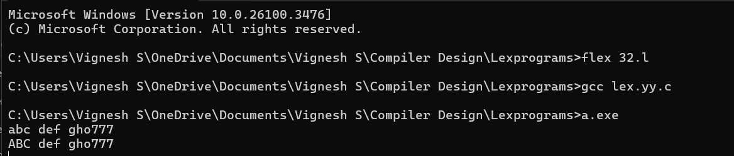

Question 33:

CODE:

%{

#include <stdio.h>

%}

DIGIT [0-9]+

ID [a-zA-Z_][a-zA-Z0-9_]*

KEYWORD "int"|"float"|"if"|"else"|"return"|"while"

%%

{KEYWORD} { printf("Keyword: %s\n", yytext); }

{ID} { printf("Identifier: %s\n", yytext); }

{DIGIT} { printf("Number: %s\n", yytext); }

.|\n { /* Ignore other characters */ }

%%

int main() {

yylex();

return 0;

}

int yywrap() {

return 1;

}

OUTPUT:

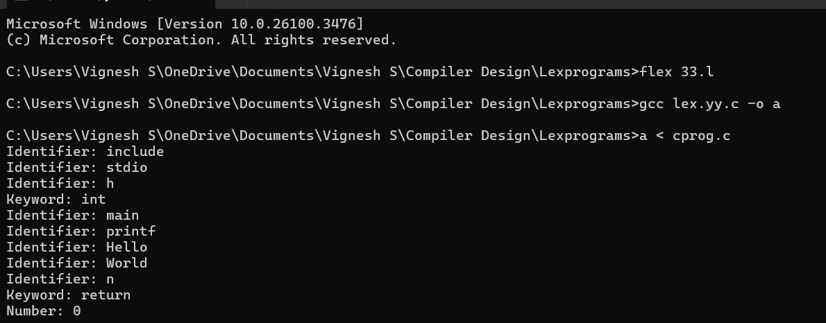

Question 34:

CODE:

%{

#include <stdio.h>

%}

KEYWORD "int"|"float"|"if"|"else"|"return"|"while"

ID [a-zA-Z_][a-zA-Z0-9_]*

%%

{KEYWORD} { printf("Keyword: %s\n", yytext); }

{ID} { printf("Identifier: %s\n", yytext); }

.|\n { /* Ignore other characters */ }

%%

int main() {

yylex();

return 0;

}

int yywrap() {

return 1;

}

OUTPUT:

